*Q1. Explain using code examples what is meant by props and state in React JS?*

*State in react refers to a components local state, this is the information associated with a component that can only be accessed within the component, eg Local Variable values.*

*Props are values passed to a component by their parent component, they allow us to make react components reusable and configurable. Below shows a printing component, which uses props to print the value passed by the parent component.*

*class PrintComponent extends React.Component {*

*render() {*

*return <span>Value: {this.props.value}</span>;*

*}*

*}*

*Q2. In functional programming, what does the term functor mean? Can you give an example in Javascript?*

*A functor is a data object which is mappable, this means that unary operations such as toUpperCase can be applied via data mapping. In the example below we are using an array as a functor with the .map() function.*

*var array = ['dom', 'lun', 'mar', 'mer', 'gio', 'ven', 'sab'];*

*var upperCasedArray = $.map(array, String.toUpperCase);*

*Q3. We have looked at three kinds of asynchronous programming mechanisms, namely callbacks, promises and streams. Mention one advantage and one disadvantage of each type*

*The advantages of using streams comes when implementing series such as a series of requests to an API eg. a search bar or other requests that don’t involve individual finite requests. It also implements all of the functionality of promises and is cancelable.*

*The main disadvantage of this over promises is that for single requests such as above it can be an overcomplication to implement a data stream.*

*The main advantage of using a promise, is that it’s simple and completely vanilla JS requiring no external libraries. For single requests it often makes more sense to use a promise for readability purposes over a stream.*

*The disadvantage of this, is promises don’t scale well and a stream is better suited to a series of requests.*

*Q4. With the aid of a diagram and example code, describe the Cascading Style Sheets (CSS) Box Model and show how it can be used to space DOM elements*

*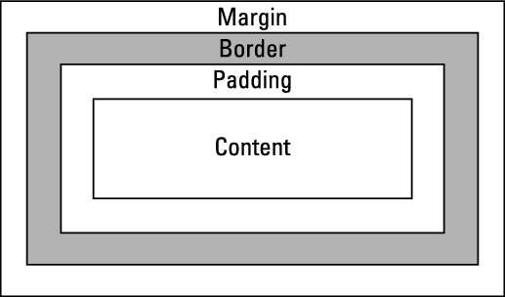*

*The CSS box model refers to the metaphorical box that surrounds each HTML element, this box has a border which refers to the lines outlining the box, a margin which refers to the space between the border and any elements the box is within and padding which refers to the space between the actual object and the border.*

*Q5. Detail how the browser loads and bootstraps a rich web application from an initial URL.*

* *URL is translated to an IP address via a DNS query*
* *Browser contacts webserver at the IP address and performs a HTTP GET request to retrieve the web page*
* *Browser begins to render Web Page, in the case of a Rich Web application a bootstrapper will load any libraries or frameworks such as react or angular from their sources and init them.*
* *Controller is loaded and rich web application “starts”*
* *CSS Styles are applied*